Internal Quarterly Report

Date of Report: 3rd Quarterly Report, July 1, 2025
Contract Number: 693JK32410013POTA
Prepared for: DOT PHMSA
Project Title: Assess and Prevent Threats in Conversion or Repurposing Pipeline Systems
Prepared by: DNV
Contact Information: Greg Morris, greg.morris@dnv.com, 614-761-1214
Tara McMahan, tara.podnar.mcmahan@dnv.com, 614-761-1214
For quarterly period ending: June 30, 2025

1: Items Completed During this Quarterly Period:

Task 1 Literature Review Draft Report 20250701 .

2: Items Not-Completed During this Quarterly Period:

Project is on schedule.

3: Project Financial Tracking During this Quarterly Period:
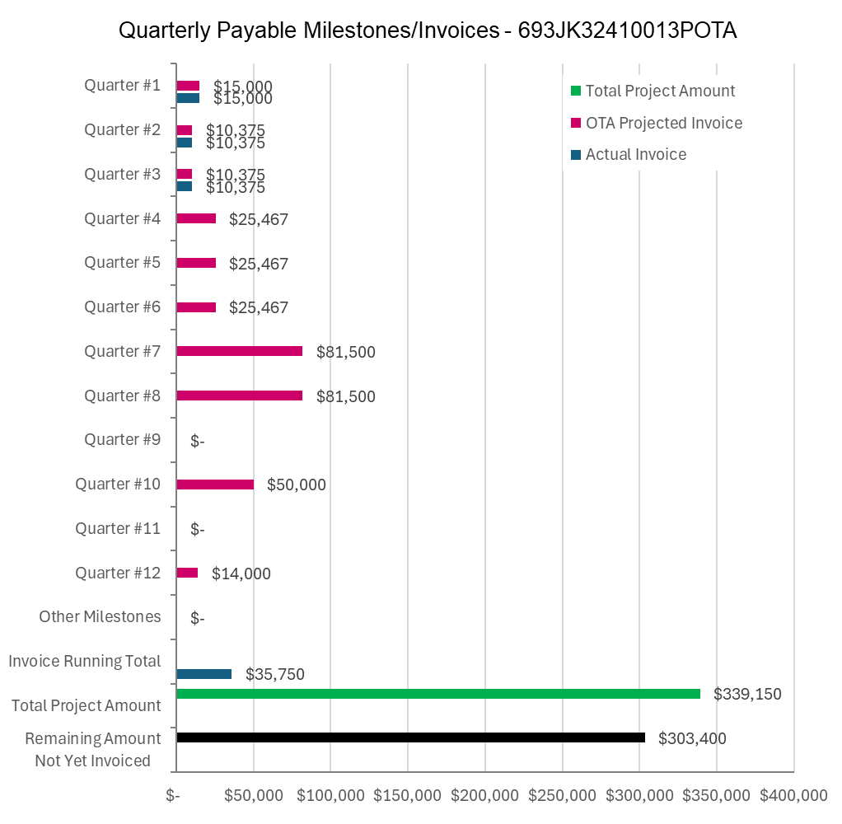

4: Project Technical Status –

DNV held the second quarterly TAP Meeting on July 1, 2025, to provide a status report on the project.

DNV informed the TAP that the Task 1 literature review draft report will be submitted to the TAP by COB July 1, and requests that the TAP indicate any noteworthy and relevant references that should be added.

DNV is continuing development of the Systematic Evaluation Process in the form of flowcharts and guidance text.

Minutes of the 2nd Quarterly TAP meeting will be posted to the project share site (PHMSA Repurposing Guidance Project - Home).

5: Project Schedule –

The project is on schedule schedule.

